WRIT 302: EDITING
Fall 2026 | Tues/Thurs 10– 11:15 a.m. | Instructor: Dr. Catherine Gouge

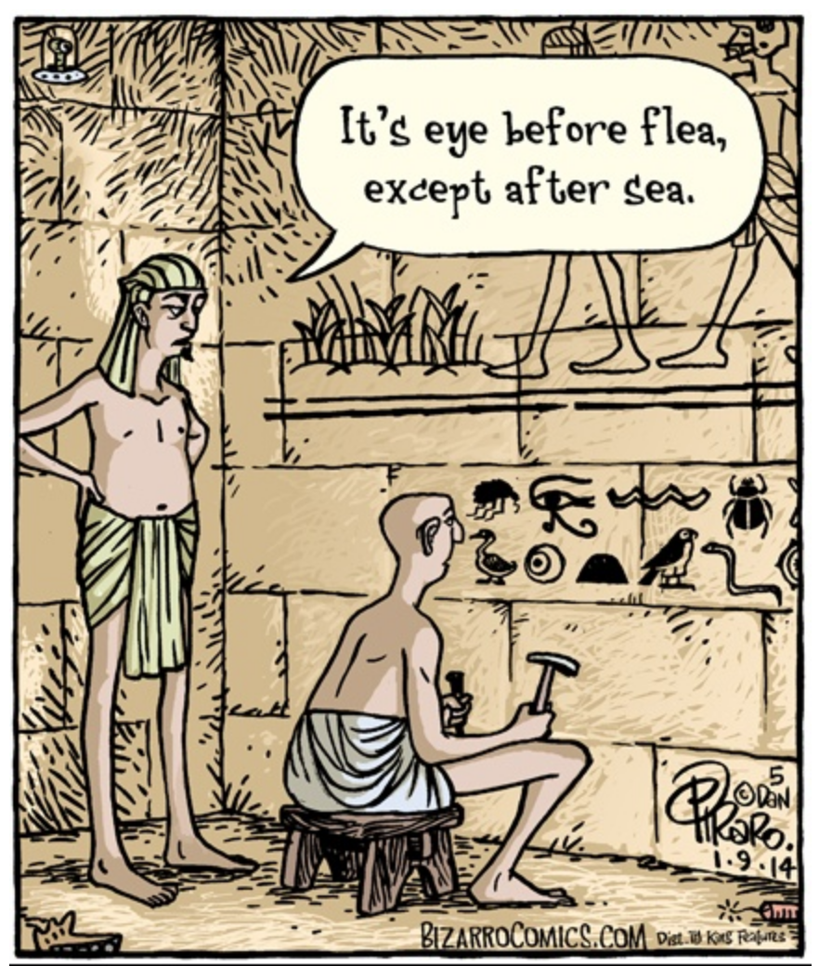
Editing is fundamental to effective texts—now as much as, if not more than, ever. No matter how accomplished we are as writers, an effective editor can help us more fully realize our ideas, boost our prose, and think critically about rhetorical contexts. Editors engage with everything from content, punctuation, and style to a text’s page design, illustrations, and progress through the publishing process. Good editing skills can also help you improve your own writing, do your job better—no matter what that is, and (this has happened for many of my past students) pick up some freelance work.

With an emphasis on editing technical texts, all students taking this course will…

- Learn about the editing process—including manuscript editing, comprehensive editing, electronic/hardcopy editing, project management, collaboration with authors, and the roles of the editor.
- Become more fluent with the vocabulary and principles of grammar, punctuation, and style.
- Practice editing at every stage of the process.
- Have an opportunity to apply the class content to documents drawn from the publicly available materials shared by area businesses and government offices.
- Consider the roll of editing and the unique challenges editors face in a time of expanding AI use.

WRIT 302 is one course that fulfills a core requirement for all English and Writing Studies majors Professional Writing and Editing minors and concentrators. It is a highly professionalizing class, and students completing it will develop lots of valuable workplace skills—whether or not “editor” is a part of your title. Students who have taken it routinely report back about ways they are using what they have learned.
Questions? Feel free to reach out to Professor Gouge @ cgouge@mail.wvu.edu.

