Step into the World of Revolutions, Romance, and Rebels!
Enroll in ENG 262: A Survey of British Literature (1780-1930)

Explore 150 years of groundbreaking literature that changed the world!
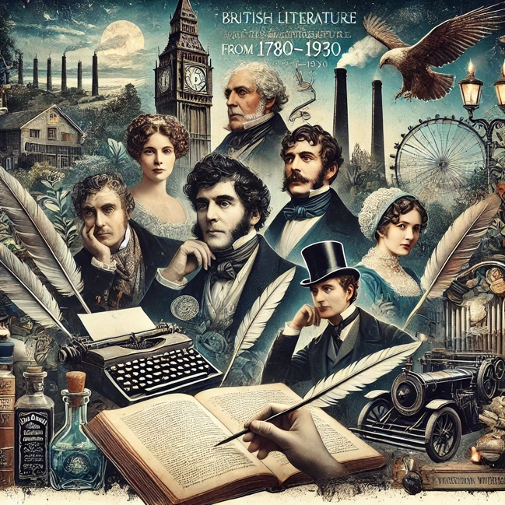
From the rise of Romanticism to the dawn of modernism, discover how British writers responded to radical social, political, and cultural changes, revolutions, industrialization, and the struggles for individual freedom. This course takes you through the most exciting period in British literary history!
Why take this course?
- Read iconic works by some of the greatest British authors, including Wordsworth, Shelley, Austen, Dickens, the Brontës, Wilde, and Woolf.
- Discuss revolutionary ideas like democracy, gender equality, and the changing concept of the self.
- Understand the historical and cultural backdrop that shaped these literary masterpieces, from the French Revolution to World War I.
- Engage in lively class discussions on how literature both reflected and influenced a rapidly changing world.

Who should enroll?
- Students who love literature, history, or philosophy.
- Those curious about how writers responded to crises of identity, politics, and social order.
- Anyone interested in exploring themes of love, rebellion, progress, and personal freedom.

What you’ll gain:
- A comprehensive understanding of British literary movements, from Romanticism to Modernism.
- The ability to critically analyze and appreciate complex texts.
- Insight into how literature reflects and influences society, then and now.

Class Details:
- Course Title: A Survey of British Literature (1780-1930) (ENG 262)
- Semester: Spring 2026
- Meeting Times: MWF 11:30 -12:20
- Instructor: Professor Stewart
- Prerequisites: None

