**The Celtic World**

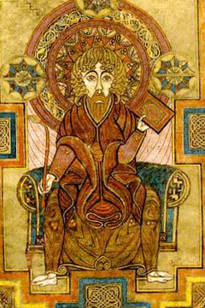

**ENGL 393B, TuTh 1:00-2:15**

**Professor Farina**

The ancient Celts have fascinated many people who came after them—not only their own descendents but writers, artists, and historians from the 11th century to the present. These distant and somewhat enigmatic people have a strong hold on our own popular imagination: contemporary film, television, comic books, and romance fiction abound with Celtic-inspired fantasy. More disturbingly, ethnocentric political factions recruit the Celtic past for their own, darker fantasies of racial purity.

This course provides an introduction to the literature, art, and history of “Celtic” peoples before 1600: i.e. the Irish, Welsh, Scots, Cornish, and Bretons. “Celtic” is here in quotes because one of our main inquiries will be whether there was or is something like a truly pan-Celtic identity. In order to understand whether “Celticness” is an ancient or modern phenomenon, we will also discuss how the early Celts have been represented in later periods. Other topics to be discussed include: the Celtic hero (particularly Cú Chulainn and King Arthur); the Celtic Otherworld; Bardic poetry; and Celtic Christianity.

**Readings:**

*The Book of Invasions; The Tain Bo Culaigne, The Mabinogi, Lives of St. Patrick and St. Brigit*

Gerald of Wales’s *History and Topography of Ireland*; Geoffrey of Monmouth’s *History of the Kings of Britain* and *Life of Merlin,* Marie de France’s *Lais*; and *Sir Gawain and the Green Knight*

Please note that this is a discussion-based class and will require you to verbalize your thoughts about the readings on a regular basis.