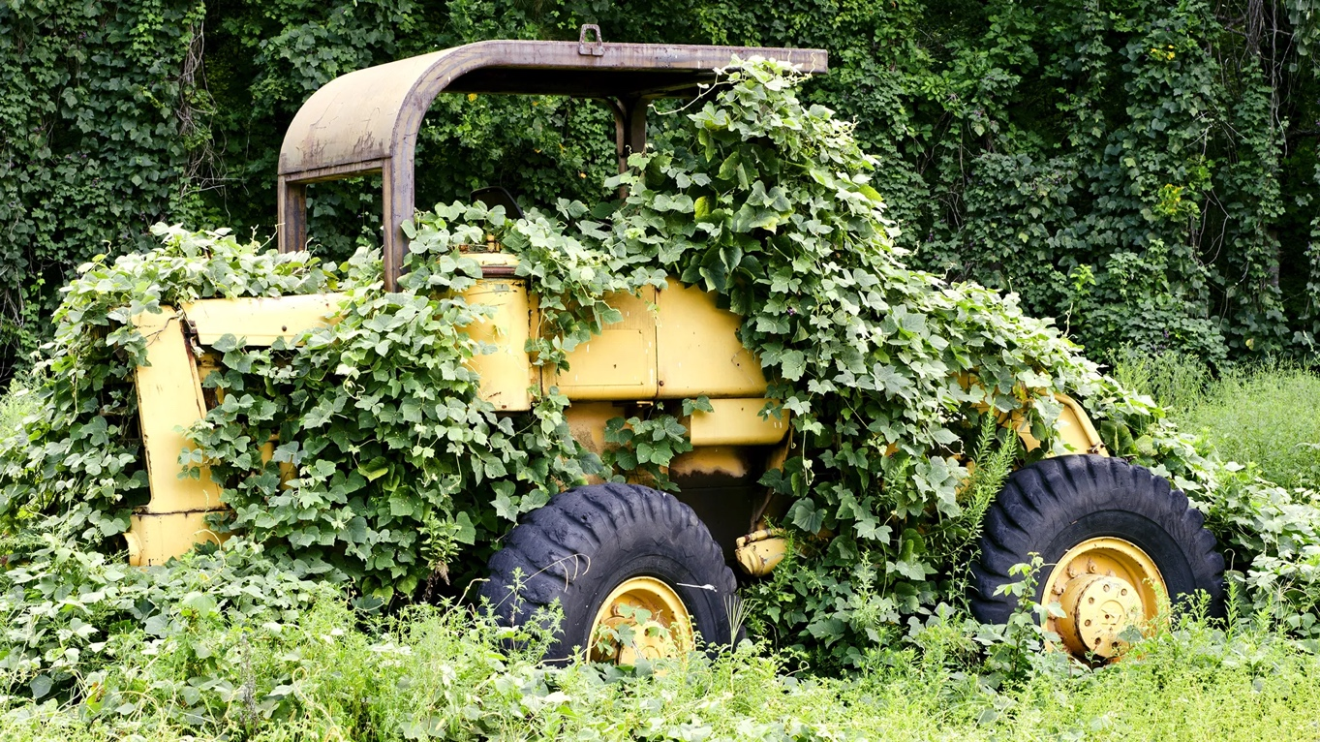

GREEN WORLDS
ENGL 293A, TuTh 2:30-3:45
Prof. L. Farina

What’s it like to be a plant? To be rooted? To live for centuries or only a season? While science and philosophy offer some answers to these questions, fiction, art, and other creative practices have produced equally compelling ways of thinking about vegetal life. This course offers a history of human imagination of “green worlds,” from Classical antiquity to the present, and from natural philosophy to science fiction. We will discuss human/nonhuman relations, the dramatization of botanic life, “plant horror” and human vegetality, the social life of green space, and speculative ecologies.
Literary texts and films will include: Ovid’s Metamorphoses, Sir Gawain and the Green Knight, Shakepeare’s Midsummer Night’s Dream, Charles Chestnut’s The Conjure Woman, Invasion of the Body Snatchers, Alan Moore’s Swamp Thing, and Jeff Vandermeer’s Annihilation. Course readings will also include works of philosophy, botany, and Indigenous plant knowledge.
Note: This course is cross-listed as an honors class, but English Majors need not be honors students to enroll. It is a seminar-style discussion-based class, so speaking in class on a regular basis is required.

