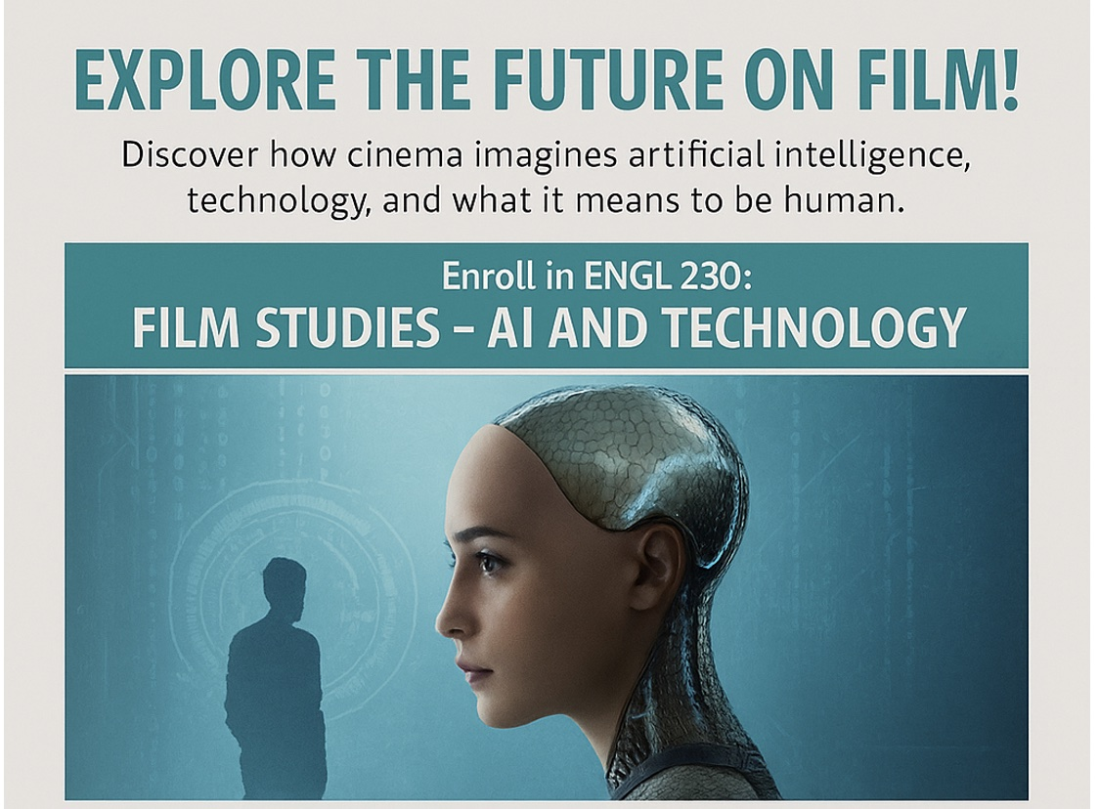
Why take this course?
- Watch groundbreaking films like Metropolis, 2001: A Space Odyssey, Blade Runner, Her, Ex Machina, and select Black Mirror episodes.
- Explore big questions about machine consciousness, surveillance, love, identity, and the blurred line between human and AI.
- Learn how to analyze films critically, not just for their stories but for their use of cinematography, editing, sound, and visual design.
- Connect cinema to philosophy, culture, and the future of technology.
Who should enroll?
- Students curious about how film reflects and shapes debates about AI and technology.
- Anyone interested in the intersection of art, culture, science, and the future.
- Those who want to strengthen their skills in analysis, writing, and cultural critique.
What you’ll gain
- A critical toolkit for watching and analyzing film techniques.
- Insights into how cinema engages with cultural debates on AI and posthumanism.
- A deeper understanding of how narratives shape, and are shaped by, technology.
Class Details
- Course Title: Film Studies : AI and Technology (ENGL 230)
- Semester: Spring 2026
- Meeting Times: Monday, Wednesday, Friday | 10:30–11:20 AM
- Instructor: Professor Stewart
- Prerequisites: None.

