ENGLISH 312: ADVANCED READING AND FICTION
Professor: Christa Parravani

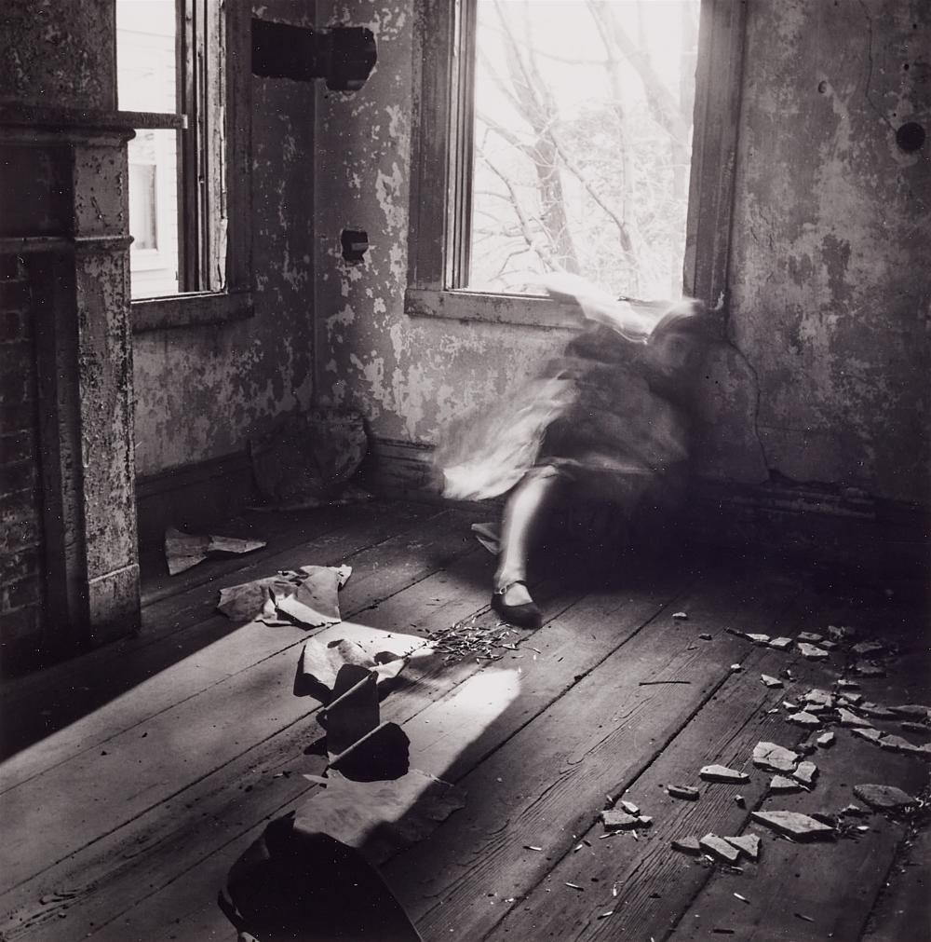

English 312 focuses on the intensive writing of short stories. This course picks up where 212 leaves off—here we’ll strive to master plot, sentence structure, deepen character, believability, place, point of view, and narrator reliability. We will read contemporary short stories, write two pieces of full-length fiction, and engage in weekly peer review. This class is for every fiction writer who hopes to elevate their craft, and maybe even start a lifelong practice of reading and writing.

