ENGL 371 001/H01: Modern British and Irish Literature F26
Fall 2026
MWF 10:30am-11:20am
Prof. Lisa Weihman
lgweihman@mix.wvu.edu

“The Centre Cannot Hold”
Modernist Literature and the Dislocation of the Self

This course will offer a focused study of how the Great War altered literary representations of the self in England and Ireland, with specific reflections on constructions of gender and nation. Included will be a variety of texts from different genres by modernist authors including Sassoon, Owen, Rosenberg, Yeats, Woolf, Joyce, Mansfield, and others.

Major assignments include two short papers (5pp), one of which will be the foundation for a 10-12pp research essay.

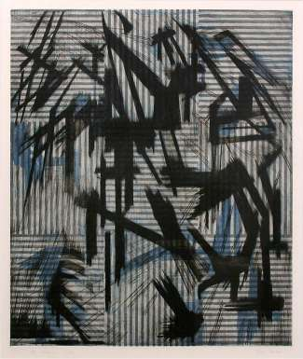

The Falcon Cannot Hear The Falconer by Tessa Beaver, University of Warwick

