Unlock the Mysteries of the Mind!
Enroll in ENG 170: Literature of the Self
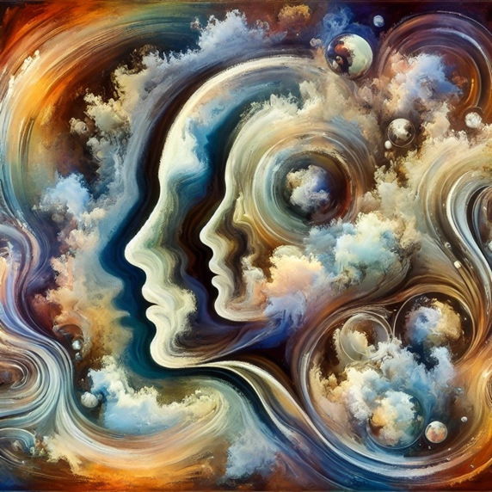
What does it mean to be human? How do our experiences, identities, and the world around us shape our consciousness and sense of self?
In this course, you will explore the complexities of consciousness, selfhood, and what it means to be human. This is no ordinary journey. Our focus will be on characters and narratives that push the boundaries of the "normal," diving into stories of disability, trauma, monstrosity, criminality, and more.
Why take this course?
- Explore thought-provoking topics like trauma, human rights, queer identities, and posthumanism through works of literature.
- Dive into narratives featuring characters that challenge conventional ideas of selfhood such as monsters, criminals, animals, and more.
- Engage with critical questions about the human mind, identity, and how we understand others who deviate from societal norms.

Who should enroll?
- Students interested in literature, philosophy, psychology, or cultural studies.
- Those who want to explore the connections between mind, selfhood, and identity in groundbreaking and unconventional ways.
- Anyone fascinated by how characters that fall outside the norm can reflect deeper truths about the human condition.

What you’ll gain:
- A critical understanding of the ways in which literature depicts consciousness and selfhood.
- The ability to analyze complex characters and narratives that challenge norms of humanness and identity.
- Insights into evolving cultural, ethical, and philosophical questions about what it means to be human.

Class Details:
- Course Title: (ENG 170) Literature of the Self
- Semester: Spring 2026
- Meeting Times: MWF 9:30-10:20
- Instructor: Dr. David Stewart
- Prerequisites: None

