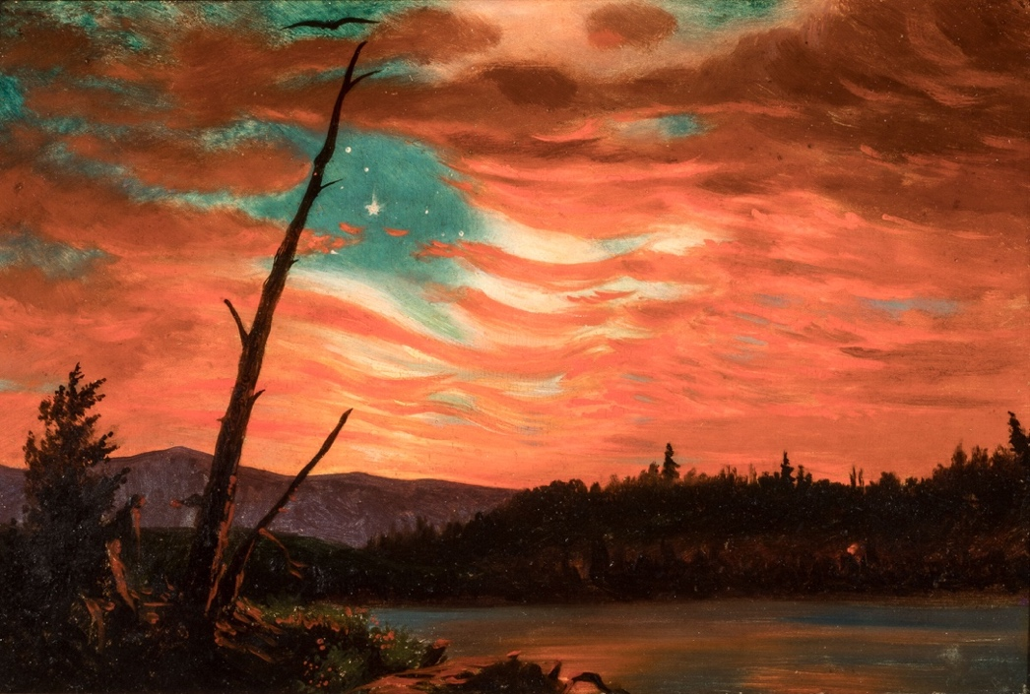
ENGL 646
American Literature, beginnings to 1865

Fall 2025
Tuesday 4:00-6:50
Colson 223

Tim Sweet
tsweet@wvu.edu
213 Colson
Tues. 3-4 and by appt.

Frederick Church,
Our Banner
in the Sky
1861
Overview
We’ll balance close and distant reading as we address four interrelated topics: “American” (what does that mean?) literary and cultural history, canon formation, the function of the survey in the present state of the discipline, and practical matters of designing and teaching a survey. Although the primary readings are period- and nation- specific, the practical and theoretical questions are broadly applicable to other literatures.

Texts
Robert Levine et al., eds., The Norton Anthology of American Literature, 10th ed., vols. A and B (2022) 9780393884425 (Please buy the hard copy.)
Toni Morrison, “Unspeakable Things Unspoken” (1989)
Joseph Csicsila, Canons by Consensus (2004), excerpts
Ted Underwood, Why Literary Periods Mattered (2013), Introduction
John Guillory, “Uses of the Survey Course,” ADE Bulletin (2015)
Erik Fredner and J. D. Porter, “Counting on The Norton Anthology of American Literature,” PMLA 139.1 (Jan. 2024): 50-65

Assignments
Weekly reading responses, 500 words in which you demonstrate broad familiarity with all the assigned readings and deep engagement with some, including some of those marked as supplementary. 10 combined = 30% of your course grade.
A presentation on current scholarship on a week’s primary readings, with questions drawn from the scholarship as prompts for discussion. 10%
Oral poetry recitation in class. Required but not graded.
Anthology project: identify an early (pre-1820) text that is not in the Norton and argue for its inclusion (1000 words + text to be printed). Locate this text with respect to the Norton’s organizational scheme and table of contents. Identify a text or texts of equivalent length in the Norton that you’d cut to make room for your addition and give a rationale. 20%
A sample syllabus for a 15-week undergrad survey course, plus 1500-word rationale based on the understanding of American literary history that you intend your syllabus to present. 40%
Policies

Late work will not be accepted. If you must miss class for any reason, including illness, you should still submit any assignment due by the deadline listed in the syllabus. In cases of debilitating illness, we will work together to devise a schedule for the completion of course work.
AI. I expect that the work you submit to me will represent your own thinking and your own writing. If you do use a generative AI tool as part of your writing for an assignment (e.g., to brainstorm or to refine a research question), I expect you to cite the tool used and to attach a cover memo explaining how and why you used the tool. Failure to do so is an academic integrity violation.
Inclusivity. WVU’s Diversity, Equity, and Inclusion office has been replaced by the Division of Campus Engagement and Compliance. Although recent legislation attempts to limit WVU’s formal commitment to creating and fostering a positive learning and working environment based on open communication, mutual respect, and inclusion, we in this class need not feel so limited.
Accessibility. If you are a person with a disability and anticipate needing any type of accommodation in order to participate in your classes, or if you have any difficulty accessing course materials due to their mode of existence on the syllabus or textbook, please advise me and make appropriate arrangements with the Office of Student Accommodations (304) 293-6700, which has replace Accessibility services.
Sexual Misconduct. WVU does not tolerate sexual misconduct, including harassment, stalking, sexual assault, sexual exploitation, or relationship violence. (BOG Rule 1.6) It is important for you to know that there are resources available through the Title IX office if you or someone you know needs assistance. The 24/7 Title IX anonymous Hotline can be reached at (304) 906-9930. You may speak to a member of university administration, faculty, or staff; keep in mind that they have an obligation to report the incident to the Title IX Coordinator. If you want to speak to someone who is permitted to keep your disclosure confidential, please seek assistance from the Carruth Center (304) 293-4431 (24-hour hotline), or locally within the community at the Rape and Domestic Violence Information Center (RDVIC), (304) 292-5100 (24-hour hotline).
Mental health concerns or stressful events can adversely affect your academic performance and social relationships. WVU offers services to assist you with addressing these and other concerns that you may be experiencing. You can learn more about the broad range of confidential mental health services available on campus at the Carruth Center website. If you are in need of crisis services, call the Center’s main number 24/7: (304) 293-4431. Crisis services are also available through text: Text WVU to 741741 for support 24/7 from a trained Crisis Counselor.

Graduate Writing Studio.

The Graduate Writing Studio assists any master's or doctoral student in the development of the professional skills necessary to complete their graduate programs successfully and prepare for future positions within and beyond the university. Professional and friendly consultants work one-on-one with writers on all aspects of their academic and professional writing. The Studio also offers writing groups, writing retreats, and occasional workshops. To make an appointment, follow the link on their website or drop by G02 Colson Hall.

Schedule

All readings are from Robert Levine et al., eds., The Norton Anthology of American Literature, 10th ed., vols. A and B (2022) 9780393884425, except those separately linked.

Focus readings are listed in clear text. Supplementary readings are shaded. For your responses, concentrate on the focus reading but also include some of the supplementary readings, comparing or contrasting them with the focus readings.

Weekly responses are due by 1pm on the day the class meets. Due dates for the assignments beyond the weekly readings are listed in bold.

8/26 | Introductions and Timelines, A.3-28, B.3-24
9/2 | Indigenous oral texts: Iroquois creation, Navajo creation, Winnebago trickster, Powhatan’s Discourse, King Philip’s Speech  Encounter narratives cluster A.76-104  Colonial promotion: Smith, General History  First generation New England: Bradford, Of Plymouth book II; Winthrop, “Model of Christian Charity,” journal entries on Anne Hutchinson (186-90); Williams, Key into the Language of America; Bradstreet, “Prologue,” “In Honor of Elizabeth,” “In Memory of My Father,” “Contemplations,” “In Memory of My Dear Grandchild Elizabeth”  Indigenous oral texts: poetry  Spanish exploration and conquest: Columbus, Las Casas, Cabeza de Vaca  Colonial promotion: Smith, Description of NE, NE’s Trials; Morton  First generation New England: Bradford, Of Plymouth book I; Winthrop, other journal entries; Bay Psalm Book; Williams, “Christenings”; Bradstreet, other poems
9/9 | Second and third generation New England: Rowlandson, Captivity; Taylor, Meditation 8, “Upon a Wasp”; Sewall, “Selling of Joseph,” Mather, Wonders of the Invisible World  Great Awakening: Edwards, “Personal Narrative,” “Sinners in the Hands of an Angry God”; Occom, Sermon at the Execution of Moses Paul  Ethnographic and naturalist writings cluster, A.531-51  Second and third generation New England: Wigglesworth, Day of Doom; Taylor, other poems; Sewall, Diary; Mather, Magnalia Christi Americana, Bonifacius  Great Awakening: Edwards, “Sarah Pierpont,” “Sarah Edwards,” “Divine and Supernatural Light”; Occom, Narrative, hymns  Captivity narratives cluster, A.294-304  Religious expression cluster, A.407-28
9/16 | Atlantic World: Equiano, Interesting Narrative chapters I-VII  Enlightenment and Revolution: Franklin, “Way to Wealth,” “Polly Baker,” “Rules by which a Great Empire,” Information for Those Who Would Remove,” “Remarks Concerning the Savages”; Crèvecoeur, American Farmer letters III, IX, XII; Stockton, poems; Abigail Adams letter March 31, 1776; Paine, Common Sense; Jefferson, Autobiography (Declaration of Independence);  Atlantic World: Equiano, Interesting Narrative chapters XI-XII  Enlightenment and Revolution: Franklin, Autobiography; Crèvecoeur, American Farmer letter X; Stockton; Adams & Adams letters; Paine, Crisis no. 1, Age of Reason; Jefferson, Notes on Virginia; Federalist
9/23 | Early Federal: Murray, “Desultory Thoughts”; Freneau, all poems; Wheatley, “On Being Brought from Africa,” “To Cambridge,” “On the Death of Whitfield,” “To General Washington”; Foster, Coquette  Native American negotiation and resistance cluster, A.883-93  Early Federal: Murray, “Equality of the Sexes”; Wheatley, other poems and letters; Tyler, Contrast; Brown, “Somnambulism”; Irving, History of New York
9/30 | Literary nationalism: Irving, “Rip Van Winkle”; Cooper, Pioneers; Sedgwick, Hope Leslie; Sigourney, “First Slave Ship,” “Indian Names”; Bryant, “Sonnet—To an American Painter,” “Prairies”  Indigenous voices: Apess, Indian’s Looking Glass; Schoolcraft, all poems and stories  Removal and Resistance cluster B.284-303  Literary nationalism: Irving, “Sleepy Hollow”; Cooper, Last of the Mohicans; Sigourney, other poems, Bryant, other poems  Indigenous voices: Apess, Son of the Forest
10/7 | Meet in 130 Colson, Guest speaker: Kristina Bross, University of Ohio  Ralph Waldo Emerson, “Quotation and Originality” (lecture 1859, published in Letters and Social Aims 1875)  Jason Edward Lewis, Hemi Whaanga, and Ceyda Yolgörmez, “Abundant Intelligences: Placing AI within Indigenous Knowledge Frameworks,” AI and Society 40 (2025): 2141-2157.  Anthology project due
10/14 | Reform and activist writing: Child, Letters from NY; Douglass, Narrative, “Fourth of July”; Fuller, “Great Lawsuit”: Jacobs, Incidents  Women’s Rights cluster B.666-92  Reform and activist writing: Child, “The Quadroons”; Fuller, review of Douglass, “Fourth of July”; Douglass, My Bondage, Life and Times; Brown, Narrative of the Life and Escape  Slavery and Race cluster B.736-59
10/21 | “American Renaissance”: Emerson Nature, “Divinity School Address,”; Hawthorne, “My Kinsman,” “Young Goodman Brown,” “Birth-Mark”; Thoreau, from Walden chapters 1, 7, 16, 17, 18; Melville, from Moby-Dick, “Benito Cereno”; Whitman, “Song of Myself,” “Crossing Brooklyn Ferry,” “As I Ebb’d,” “Live Oak, with Moss”  “American Renaissance”: Emerson, “American Scholar,” “Self-Reliance,” “Poet,” “Experience,” “Thoreau”; Hawthorne, “May-Pole,” “Black Veil,” “Rappacccini’s Daughter,” Scarlet Letter, Preface to Gables; Thoreau, “Resistance to Civil Government,” other chapters from Walden, “Slavery in Massachusetts”; Melville, “Hawthorne,” “Bartleby,” “Paradise . . . Tartarus”; Whitman, Preface to Leaves of Grass, other poems B.1166-1232
10/28 | Midcentury poetry: Sigourney, “Fallen Forests”; Bryant, “To a Waterfowl”; Longfellow, “Psalm of Life,” Evangeline, “Jewish Cemetery,” “Paul Revere’s Ride”; Whittier, “Hunters of Men,” “Ichabod,” “Telling the Bees”; Poe, “To Helen,” “The Raven,” “Ulalume,” “Annabel Lee”; Harper, all poems; Dickinson, poems TBA  Midcentury Poetry: Emerson, poems B. 278-82; other anthologized poems by Sigourney; Longfellow; Whittier, Snow-Bound; Poe, other poems; Dickinson, other poems  Poetry recitation in class
11/4 | Midcentury fiction: Poe, “House of Usher,” “Masque of the Red Death,” “Purloined Letter”; Stowe Uncle Tom’s Cabin; Brown, Clotel; Ridge, Joaquín Murieta; revisit Fern, Ruth Hall  Midcentury fiction: Poe, other stories; Davis, “Life in the Iron Mills”
11/11 | Civil War: Lincoln, “House Divided,” “Gettysburg Address,” “Second Inaugural”; Thoreau, “Plea for John Brown,”; Henry Timrod, “Ethnogenesis”; Whitman, Drum-Taps; Melville, Battle-Pieces; Whittier, “Barbara Frietchie”  Civil War cluster B.1577-1623  Whitman, “When Lilacs Last in the Dooryard Bloom’d”
11/18 | Toni Morrison, “Unspeakable Things Unspoken” (1989)  Joseph Csicsila, Canons by Consensus (2004), Introduction & chapter 1 (notes)  Ted Underwood, Why Literary Periods Mattered (2013), Introduction (notes)  John Guillory, “Uses of the Survey Course,” ADE Bulletin (2015)  Erik Fredner and J. D. Porter, “Counting on The Norton Anthology of American Literature,” PMLA 139.1 (Jan. 2024): 50-65  Exploring Anthologies of Early American Literature (Washington University in St. Louis)
11/25 | Thanksgiving recess
12/2 | Draft of final project due for peer review
12/9 | Presentations on final projects
 | Final project due Friday, December 12

