Appalachian Fiction
No Prerequisites
English 252, Section 001, CRN 16228
Spring 2025
11:30-12:45 p.m., TTh
Dr. Anna Elfenbein (aself@wvu.edu)
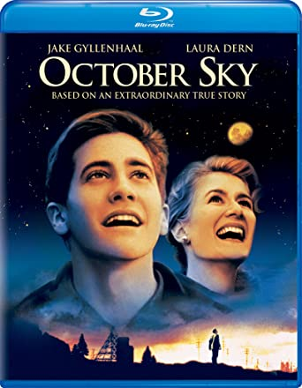

With particular attention to West Virginia authors and their works, English 252 explores literature, movies, music, and art from our region. We will screen movies and documentaries and read and discuss selected poetry and prose and novels such as Denise Giardina’s Storming Heaven and Ann Pancake’s Strange as this Weather Has Been, and a selection of writings on our English 252 eCampus Required Readings tab and on Voices of West Virginia https://www.voicesofwv.org/

Requirements

Reading Required Novels and Reading Assignments, including
eReserve Movie Viewings
Class Attendance, Open-Mics, Reading Checks, Packback Discussions

