ENGL 386 British Women Writers
FALL 2026
MWF 2:30pm – 3:20pm
Prof. Weihman
lgweihman@mix.wvu.edu

“I am made and remade continually. Different people draw different words from me” – Virginia Woolf, The Waves, 1931

This course examines fiction, poems, essays, and drama written by British women writers. We will explore what it means to be British, a woman, and a writer, categories that are historical, social, political, and complex. Texts will include a selection of novels, poems, plays, and essays from authors including Aphra Behn, Jane Austen, Charlotte Brontë, Virginia Woolf, and many others. You will practice the critical reading of texts, analyzing and interpreting literature within its historical context, and explore how literature reflects and effects social, political, and economic forces. You will learn to read and analyze literature and secondary critical essays, organize and compose a research paper, and practice oral communication skills through class discussion and presentations.

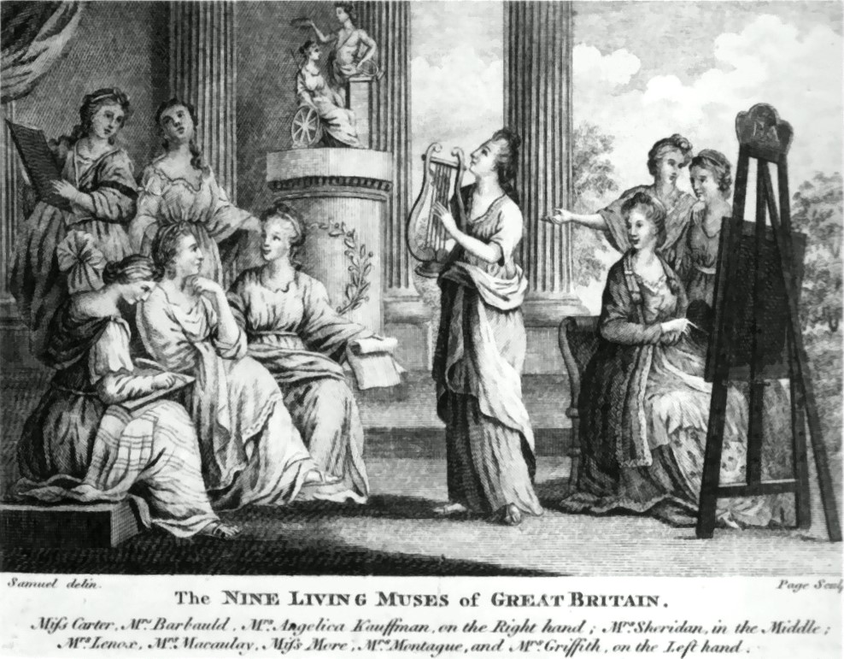

The Nine Muses of Great Britain (after similar painting by en:Richard Samuel) ref npg inc. Elizabeth Carter, Angelica Kauffman, Anna Letitia Barbauld, Catharine Macaulay, Elizabeth Montagu, Elizabeth Griffith, Hannah More, et al. By after Richard Samuel - http://needled.wordpress.com/2008/04/, Public Domain, https://commons.wikimedia.org/w/index.php?curid=9572827

