ENGLISH 212: INTRODUCTION TO READING AND WRITING FICTION
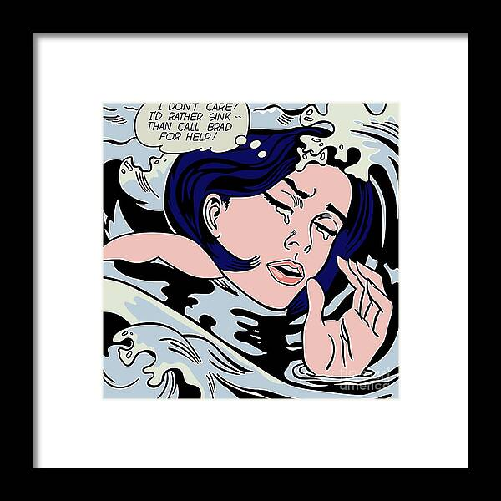

English 212 is the foundational course for studying fiction. We will read short fiction: flash, science fiction, realism, historical, and autofiction. Our material will be mostly American fiction of the last hundred years. You will craft two short stories this semester, generated through in class writing prompts. We’ll read accomplished writers, and develop a vocabulary to talk about their work. We’ll share our own work, and critique each other’s work. Be prepared to read and write with generosity and vigor. Professor: Christa Parravani

