ENGLISH 314 READING AND WRITING NON-FICTION
Professor: Christa Parravani
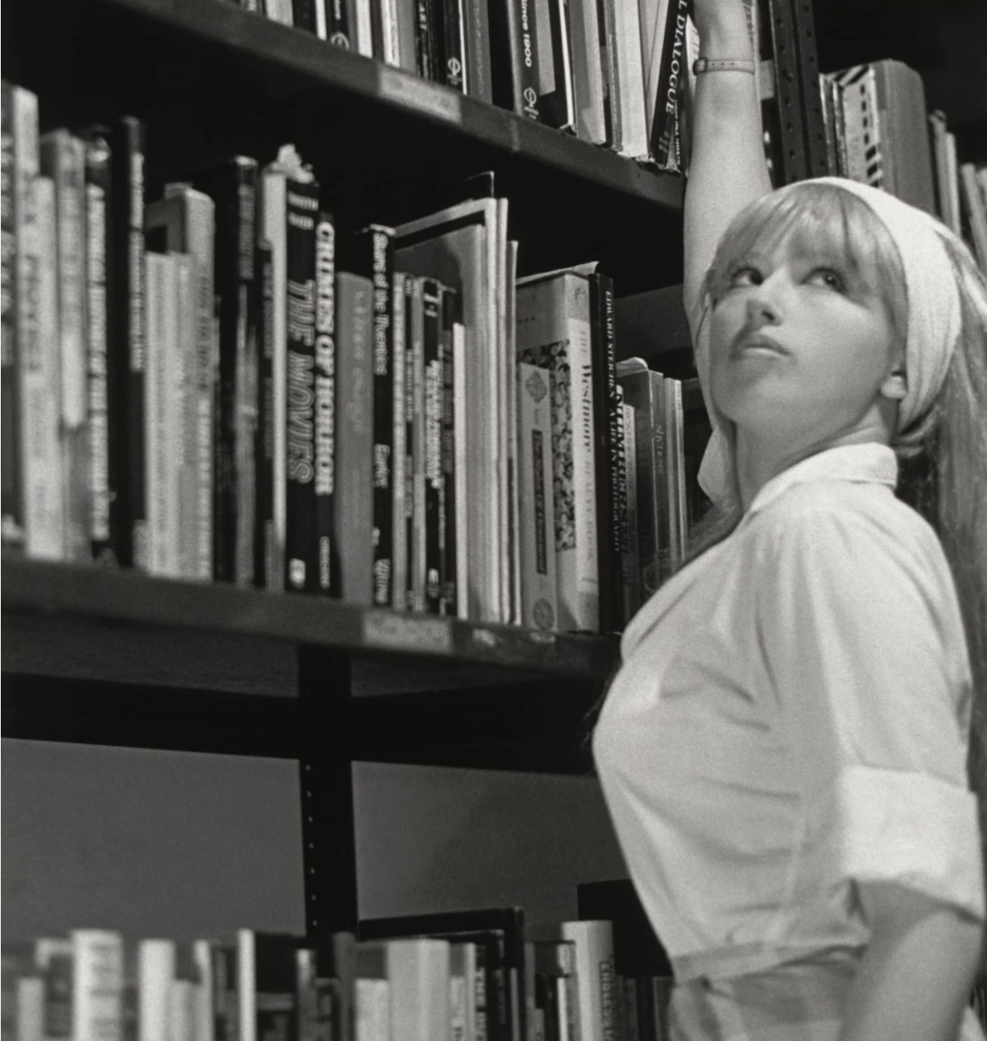

English 314 is an advanced course in reading and writing of non-fiction. We’ll focus on writing personal stories. 314 is a course which mines your heart and lets what you find live on the page. Think of all those poems and stories you’ve written having to do with You—now, let’s get to the truth; no hiding behind genre. In 314 we will create memoirs in essays. In this class we will read contemporary American nonfiction We will study various elements that make nonfiction storytelling shine: characterization, place, thematics, and tonality. English 314 will utilize the workshop model for the analysis of student work. Be prepared to write two personal essays and have fun.

